**2.Student Management Portal named StudentApp**

**Step-1:**

1. Created a studentapp react app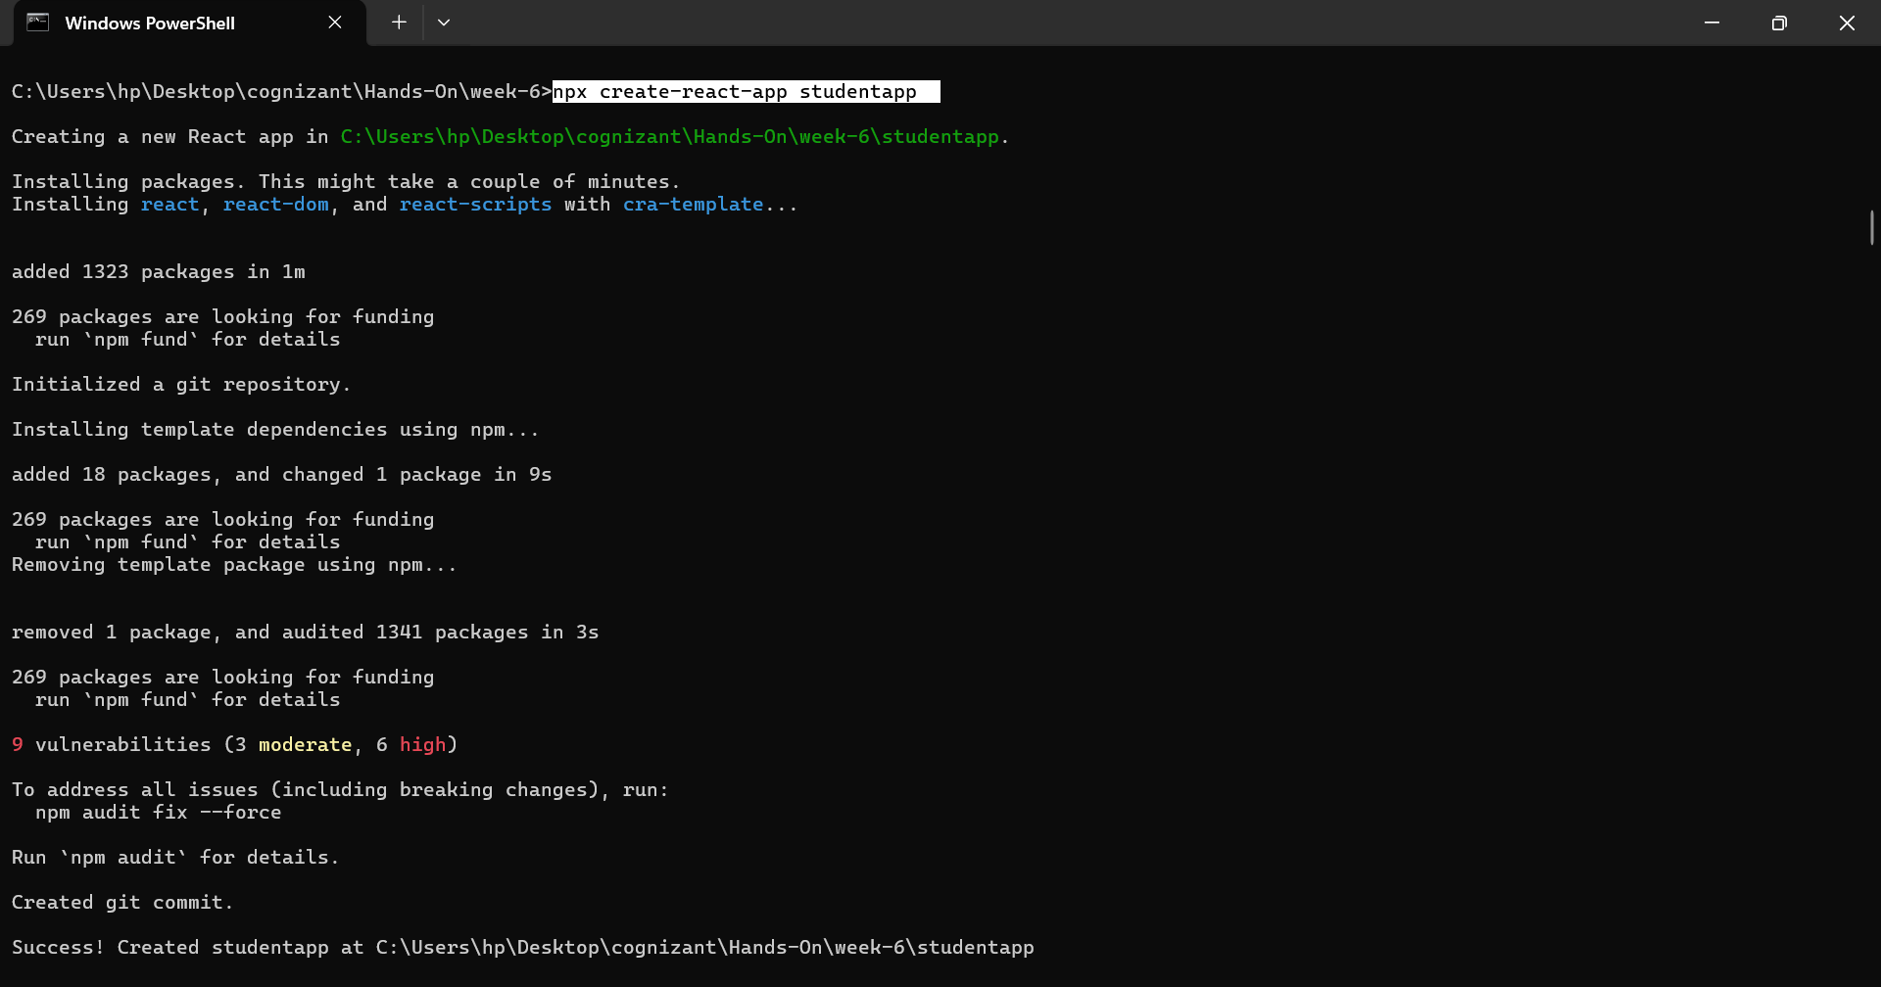
2. Added components folder in **src/** and added HomePage.js,AboutPage.js,ContactPage.js in **src/components**/

**Step-2:**

**HomePage.js**

import React from "react";

class HomePage extends React.Component {

    render(){

       return(

        <h1>Welcome to the Home page of Student Management Portal</h1>

       );

    }

}

export default HomePage;

**AboutPage.js**

import React from "react";

class AboutPage extends React.Component {

    render(){

        return(

            <h1>Welcome to the About page of the Student Management Portal</h1>

        );

    }

}

export default AboutPage;

**ContactPage.js**

import React from "react";

class ContactPage extends React.Component {

    render(){

        return(

        <h1>Welcome to the Display page of Student Management Portal</h1>

        );

    }

}

export default ContactPage;

**App.js**

import HomePage from './components/HomePage';

import AboutPage from './components/AboutPage';

import ContactPage from './components/ContactPage';

function App() {

  return (

    <>

    <HomePage/>

    <AboutPage/>

    <ContactPage/>

    </>

  );

}

export default App;

**Step-3:Output:**

